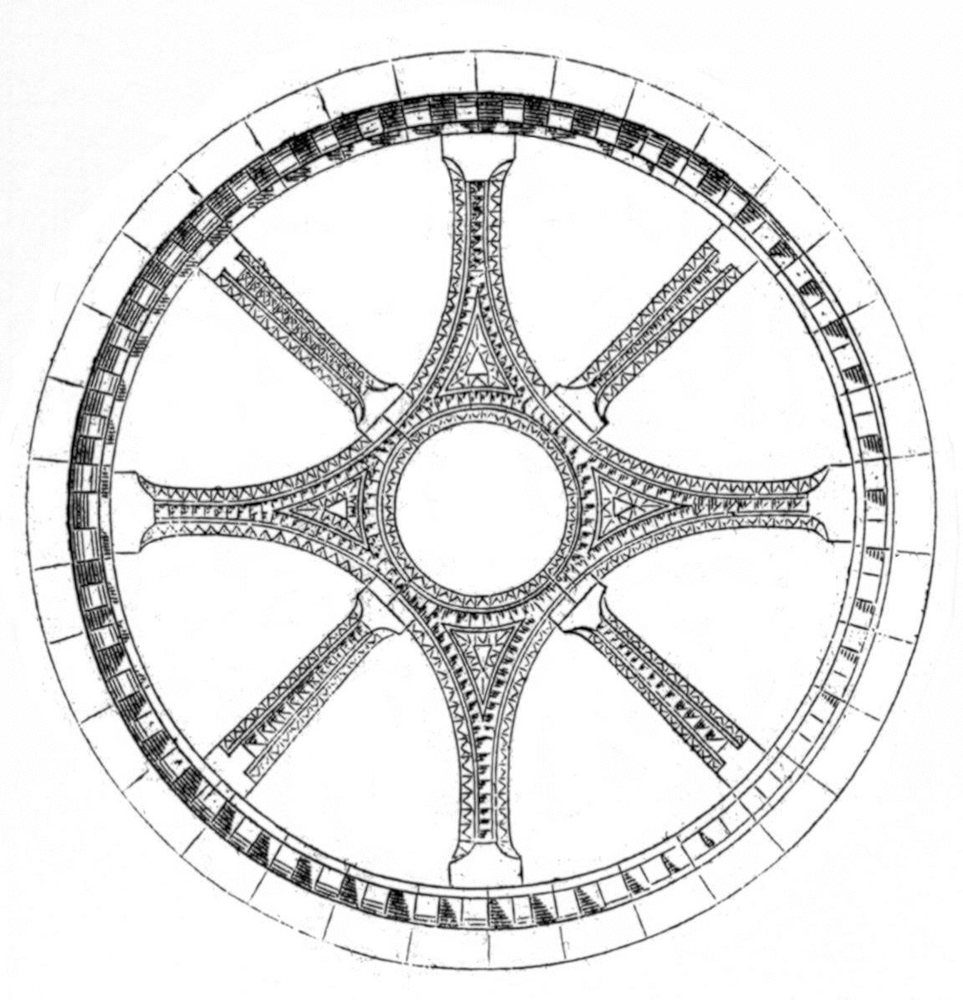
International Medieval Society - Paris
Sixth Annual Symposium on “Space”
24 – 26 June 2009

Registration Form

Name:

Affiliation:

Address:

E-mail:

Please place an X in the boxes that apply to you:

[ ] I agree to pay the membership fee in Euros (either by cash or check in Euros) on the first day of the Symposium.

[ ] I would like to be added to the IMS Members e-mail listserv.
(ims-members@yahoogroups.com).

[ ] I would like to attend the apéritif at Danielle Johnson’s house on Friday 26 June.

Membership Fee Schedule
35 euros: salaried academics
25 euros: reduced rate for students, emeriti/ae, independent scholars
100 euros or more: Friends of the Society

Please email this completed form to Meredith Cohen: m.cohen@leeds.ac.uk

